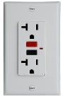**EV Charging outlets in the new USNA Garage** (rev a) 29 Mar 2018

The Congressional FAST Act allows the use of routine operating funds without special authorization for installing simple 120 volt standard convenience outlets for EV charging for employees. It also provides for simple payment in the form of routine allotment from employee’s paycheck at the rate of $6 per bi-weekly pay period for the daily use while displaying a plaquard.

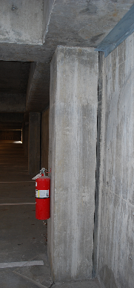**Location:** It is important not to site EV charging in prime spots, but to place them in the least desirable spots. This makes sure they are not a temptation to gas car drivers and avoids creating EV animosity among gas drivers frustrated by seeing an empty space in an ideal location.

Fortunately, the new garage has a lower level back wall that is ideal for EV charging outlets as being far from desirable exits and also being immediately adjacent to the power distribution closet also as shown here making for a trivial installation.

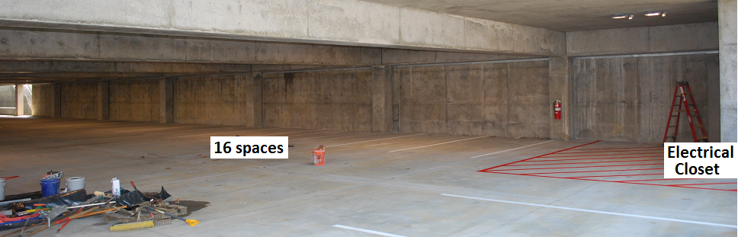

Material cost to run 100’ of conduit and 16 standard 120v outlets ($12 each) in a straight line is very low and labor is simple because the support posts left a 1” gap to the wall for the straight conduit along the wall. The labor cost is almost the same to install 1 or all 16, so they should all be done at once, on both levels. Signage later as needed.

The lower shaded deck is ideal for EV charging in summer which saves on energy by needing less air-conditioning for the drive home. For winter charging, the ideal charging wall is topside in the sun. This location is also adjacent to the electric closet immediately below it as shown here. Then entire row facing the filed should have outlets:

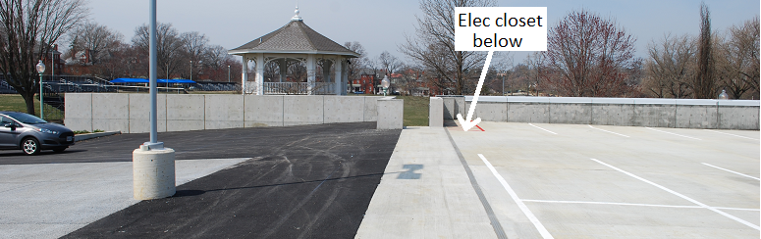

USNA should install a row of 120v standard outlets for EV charging on both parking levels and allow for employee payment as authorized in the FAST act. There are now 26 employees at USNA driving EVs and there are over 40 full size electric cars now on the market. It is time for USNA to take a leadership position as directed by Federal Executive orders to reduce carbon emissions and encouraging the use of EV’s where they are best…ie, commuting.

This routine 120v charging is independent of any plans for installing one or two faster full-speed charging stations.

Bob Bruninga, PE – x36417 – Aerospace Dept - Rickover 122